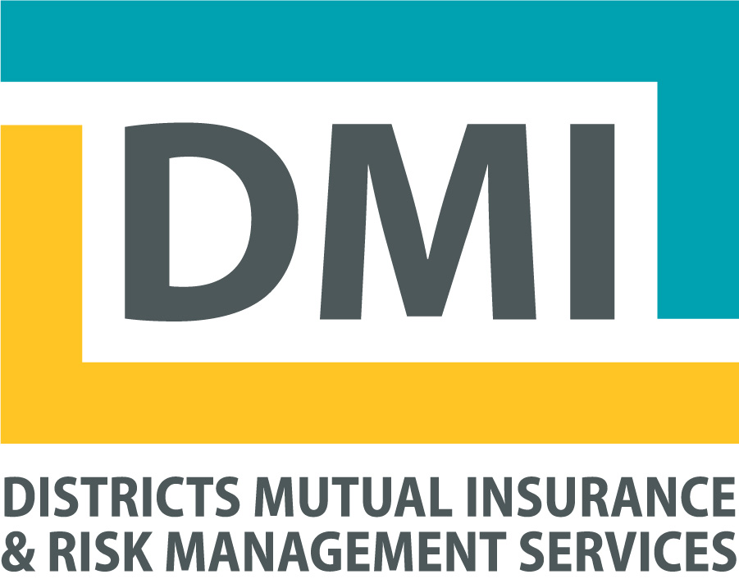
DMI Presents…
Cyber Security Forum 2018
July 24, 2018

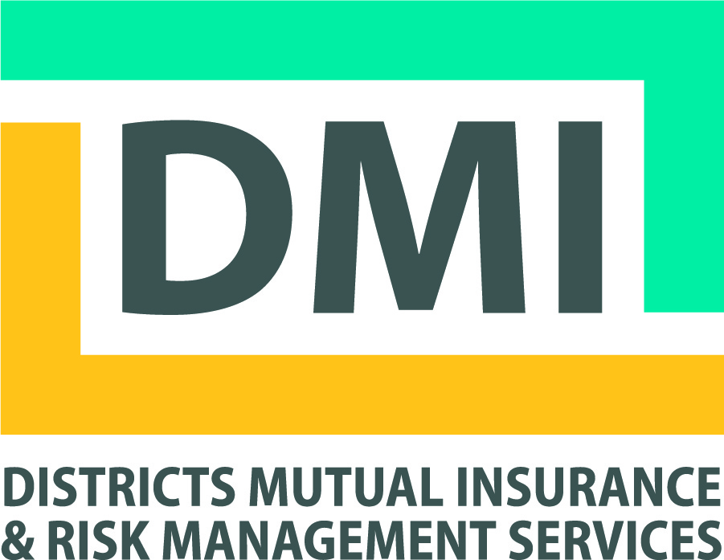
DMI Presents …. its second Cyber Security workshop; addressing comprehensive best practices in data privacy and security, regulatory compliance and much more! This program is not just for IT Managers! We encourage all members of the WI Technical College Communities to participate.

Hot Topics Include:
- FBI role in cyber crimes and FBI guidance on cyber crime risk mitigation.
- Review of changes and modifications to the Cyber Liability Policy. Review of services available through Beazley Breach Response Team, in the event of a cyber-attack.
- Higher Education Cyber Breach “Case Studies”.
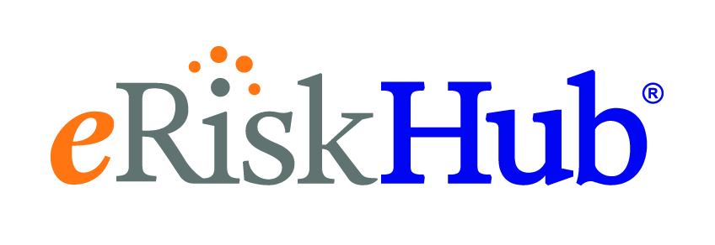
- “IT Compliance to EU Regulations General Data Protection Compliance”. GDPR Issues & Compliance Strategies for the Wisconsin Technical Colleges.
- Available Information Technology (IT) Resources.
- Technical College and Student Financial Data Privacy Requirements.
- And so much more...

Where: Radisson West Hotel When: July 24, 2018 – 10:00 am – 3:30 pm
517 Grand Canyon Drive
Madison, Wisconsin Cost: Free
Lunch: Will be provided by DMI

For: Information Technology Directors/Officers; Campus Security; Human Resource Members; Risk Managers; Environmental Health & Safety Members; Chief Operating Officers; Chief Financial
Officers; College Vice Presidents; and College Presidents

Register Today!
Attendee Information

Name: College Technical College
Title:
Telephone Number:
Email Address:
E-mail Registration Form No Later than July 13, 2018 to suzette@districtsmutualinsurance.com
For questions regarding this workshop, contact Joe DesPlaines at joe@districtsmutualinsurance.com

